WD3 indices of discard monitoring programmes

There is discards per unit effort information available from UK (flagships) and Dutch vessels sampled under the Dutch discard monitoring programme. In this document we briefly describe the discard data and the different indices of discard data.

Due to measures set by the Dutch producer organisations for coping with a restrictive TAC discarding of lower market sizes has increased.

## Dutch discard data

Discarding information of turbot is obtained from two Dutch monitoring programmes. An observer programme that has been carried out since 1999 mainly on the flatfish fleet and a self-sampling programme in a reference fleet that was set up in 2010. From 2011 onwards the observer trips have taken place on board of the fishing vessels operating in the reference fleet. Hauls are sampled during monitoring trips. These hauls are raised to haul level based on weight and hauls are raised to trip level based on fishing hours. Trips are then raised to metier level based on fishing effort (kWdays).

Effort data is obtained from logbook registrations which are reliably available since 1995.

Only sampled vessels fishing with a mesh size >70 and smaller than 100mm and registered as fishing with a TBB gear are selected for the indices.

The DpUEs obtained from both programmes are shown on figure 1. Both programmes show the same increase but the absolute differences are great. It is important to note that these DpUEs are based on a low number of observations.

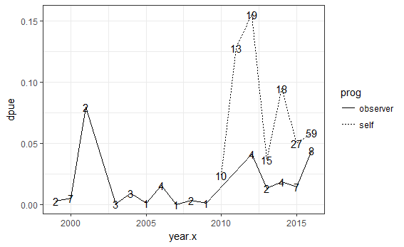

Figure : DpUEs of both discard monitoring programmes (self-sampling: dashed line, and observer: solid line). Number of observations (trips sampled) per year are shown.

Figure 2 shows the DpUE from the different monitoring programmes processed per quarter. Per quarter the number of observations are even lower and this makes comparing both programmes difficult.

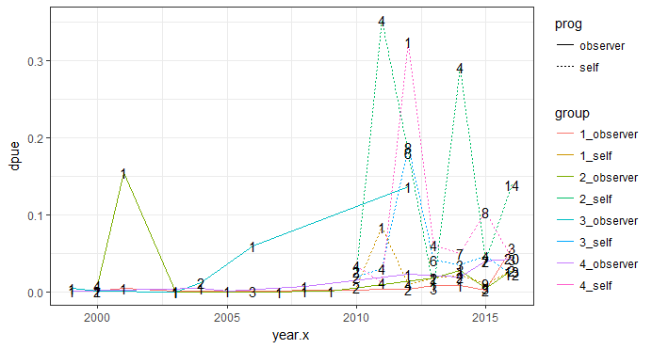

Since 2009, the Dutch fleet has transitioned to innovative gear types, replacing the beam with a wing design and replacing the tickler chains with pulse electrodes for stimuli. These changes may result in different catchabilities which is why they are also shown separately to investigate the differences. Figure 3 shows the individual DpUEs for these innovations.

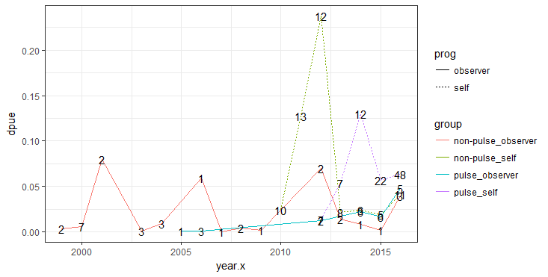

## Tables

|  |  |  |  |
| --- | --- | --- | --- |
| year.x | dpue | n | prog |
| 2010 | 0.024084 | 10 | self |
| 2011 | 0.127838 | 13 | self |
| 2012 | 0.15486 | 19 | self |
| 2013 | 0.036285 | 15 | self |
| 2014 | 0.094552 | 18 | self |
| 2015 | 0.049958 | 27 | self |
| 2016 | 0.058782 | 59 | self |
| 1999 | 0.003081 | 2 | observer |
| 2000 | 0.005477 | 7 | observer |
| 2001 | 0.079465 | 2 | observer |
| 2003 | 4.50E-04 | 3 | observer |
| 2004 | 0.009375 | 3 | observer |
| 2005 | 8.98E-04 | 1 | observer |
| 2006 | 0.015583 | 4 | observer |
| 2007 | 3.04E-05 | 1 | observer |
| 2008 | 0.003767 | 2 | observer |
| 2009 | 0.00137 | 1 | observer |
| 2012 | 0.041251 | 4 | observer |
| 2013 | 0.013511 | 2 | observer |
| 2014 | 0.018722 | 4 | observer |
| 2015 | 0.014276 | 7 | observer |
| 2016 | 0.044372 | 8 | observer |

|  |  |  |  |  |  |
| --- | --- | --- | --- | --- | --- |
| year.x | gear | dpue | n | prog | group |
| 2010 | non-pulse | 0.024084 | 10 | self | non-pulse_self |
| 2011 | non-pulse | 0.127838 | 13 | self | non-pulse_self |
| 2012 | non-pulse | 0.237547 | 12 | self | non-pulse_self |
| 2012 | pulse | 0.013111 | 7 | self | pulse_self |
| 2013 | non-pulse | 0.021113 | 8 | self | non-pulse_self |
| 2013 | pulse | 0.053624 | 7 | self | pulse_self |
| 2014 | non-pulse | 0.024153 | 6 | self | non-pulse_self |
| 2014 | pulse | 0.129752 | 12 | self | pulse_self |
| 2015 | non-pulse | 0.018929 | 5 | self | non-pulse_self |
| 2015 | pulse | 0.056703 | 22 | self | pulse_self |
| 2016 | non-pulse | 0.040846 | 11 | self | non-pulse_self |
| 2016 | pulse | 0.062893 | 48 | self | pulse_self |
| 1999 | non-pulse | 0.003081 | 2 | observer | non-pulse_observer |
| 2000 | non-pulse | 0.005477 | 7 | observer | non-pulse_observer |
| 2001 | non-pulse | 0.079465 | 2 | observer | non-pulse_observer |
| 2003 | non-pulse | 4.50E-04 | 3 | observer | non-pulse_observer |
| 2004 | non-pulse | 0.009375 | 3 | observer | non-pulse_observer |
| 2005 | pulse | 8.98E-04 | 1 | observer | pulse_observer |
| 2006 | non-pulse | 0.059235 | 1 | observer | non-pulse_observer |
| 2006 | pulse | 0.001032 | 3 | observer | pulse_observer |
| 2007 | non-pulse | 3.04E-05 | 1 | observer | non-pulse_observer |
| 2008 | non-pulse | 0.003767 | 2 | observer | non-pulse_observer |
| 2009 | non-pulse | 0.00137 | 1 | observer | non-pulse_observer |
| 2012 | non-pulse | 0.06985 | 2 | observer | non-pulse_observer |
| 2012 | pulse | 0.012653 | 2 | observer | pulse_observer |
| 2013 | non-pulse | 0.013511 | 2 | observer | non-pulse_observer |
| 2014 | non-pulse | 0.008137 | 1 | observer | non-pulse_observer |
| 2014 | pulse | 0.02225 | 3 | observer | pulse_observer |
| 2015 | non-pulse | 0.001567 | 1 | observer | non-pulse_observer |
| 2015 | pulse | 0.016394 | 6 | observer | pulse_observer |
| 2016 | non-pulse | 0.039081 | 3 | observer | non-pulse_observer |
| 2016 | pulse | 0.047546 | 5 | observer | pulse_observer |

|  |  |  |  |  |  |
| --- | --- | --- | --- | --- | --- |
| year.x | quar.x | dpue | n | prog | group |
| 2010 | 1 | 0.006215 | 2 | self | 1_self |
| 2010 | 2 | 0.026227 | 2 | self | 2_self |
| 2010 | 3 | 0.018816 | 2 | self | 3_self |
| 2010 | 4 | 0.034582 | 4 | self | 4_self |
| 2011 | 1 | 0.084318 | 1 | self | 1_self |
| 2011 | 2 | 0.351775 | 4 | self | 2_self |
| 2011 | 3 | 0.030232 | 4 | self | 3_self |
| 2011 | 4 | 0.012385 | 4 | self | 4_self |
| 2012 | 1 | 0.009433 | 4 | self | 1_self |
| 2012 | 2 | 0.180722 | 6 | self | 2_self |
| 2012 | 3 | 0.187105 | 8 | self | 3_self |
| 2012 | 4 | 0.32344 | 1 | self | 4_self |
| 2013 | 1 | 0.018055 | 2 | self | 1_self |
| 2013 | 2 | 0.005026 | 3 | self | 2_self |
| 2013 | 3 | 0.041389 | 6 | self | 3_self |
| 2013 | 4 | 0.061188 | 4 | self | 4_self |
| 2014 | 1 | 0.021665 | 4 | self | 1_self |
| 2014 | 2 | 0.290866 | 4 | self | 2_self |
| 2014 | 3 | 0.03531 | 3 | self | 3_self |
| 2014 | 4 | 0.049413 | 7 | self | 4_self |
| 2015 | 1 | 0.011145 | 9 | self | 1_self |
| 2015 | 2 | 0.040318 | 7 | self | 2_self |
| 2015 | 3 | 0.046126 | 4 | self | 3_self |
| 2015 | 4 | 0.103974 | 8 | self | 4_self |
| 2016 | 1 | 0.027291 | 13 | self | 1_self |
| 2016 | 2 | 0.139218 | 14 | self | 2_self |
| 2016 | 3 | 0.023182 | 12 | self | 3_self |
| 2016 | 4 | 0.044308 | 20 | self | 4_self |
| 1999 | 3 | 0.004715 | 1 | observer | 3_observer |
| 1999 | 4 | 0.001448 | 1 | observer | 4_observer |
| 2000 | 1 | 0.001168 | 2 | observer | 1_observer |
| 2000 | 2 | 0.00872 | 4 | observer | 2_observer |
| 2000 | 3 | 0.001122 | 1 | observer | 3_observer |
| 2001 | 1 | 0.004273 | 1 | observer | 1_observer |
| 2001 | 2 | 0.154658 | 1 | observer | 2_observer |
| 2003 | 1 | 0.001058 | 1 | observer | 1_observer |
| 2003 | 2 | 2.55E-04 | 1 | observer | 2_observer |
| 2003 | 3 | 3.69E-05 | 1 | observer | 3_observer |
| 2004 | 3 | 0.01184 | 2 | observer | 3_observer |
| 2004 | 4 | 0.004447 | 1 | observer | 4_observer |
| 2005 | 4 | 8.98E-04 | 1 | observer | 4_observer |
| 2006 | 1 | 0.001032 | 3 | observer | 1_observer |
| 2006 | 3 | 0.059235 | 1 | observer | 3_observer |
| 2007 | 2 | 3.04E-05 | 1 | observer | 2_observer |
| 2008 | 2 | 9.15E-04 | 1 | observer | 2_observer |
| 2008 | 4 | 0.00662 | 1 | observer | 4_observer |
| 2009 | 2 | 0.00137 | 1 | observer | 2_observer |
| 2012 | 1 | 0.00297 | 2 | observer | 1_observer |
| 2012 | 3 | 0.135871 | 1 | observer | 3_observer |
| 2012 | 4 | 0.023192 | 1 | observer | 4_observer |
| 2013 | 1 | 0.008964 | 1 | observer | 1_observer |
| 2013 | 2 | 0.018059 | 1 | observer | 2_observer |
| 2014 | 1 | 0.008137 | 1 | observer | 1_observer |
| 2014 | 2 | 0.028029 | 1 | observer | 2_observer |
| 2014 | 4 | 0.01936 | 2 | observer | 4_observer |
| 2015 | 1 | 0.002711 | 2 | observer | 1_observer |
| 2015 | 2 | 0.004459 | 3 | observer | 2_observer |
| 2015 | 4 | 0.040566 | 2 | observer | 4_observer |
| 2016 | 1 | 0.056934 | 3 | observer | 1_observer |
| 2016 | 2 | 0.02761 | 2 | observer | 2_observer |
| 2016 | 4 | 0.042984 | 3 | observer | 4_observer |

Figure 3. Spatial distribution of the puls, sumwing and traditional beamtrawl fleet over the years